Virtues During Collaboration

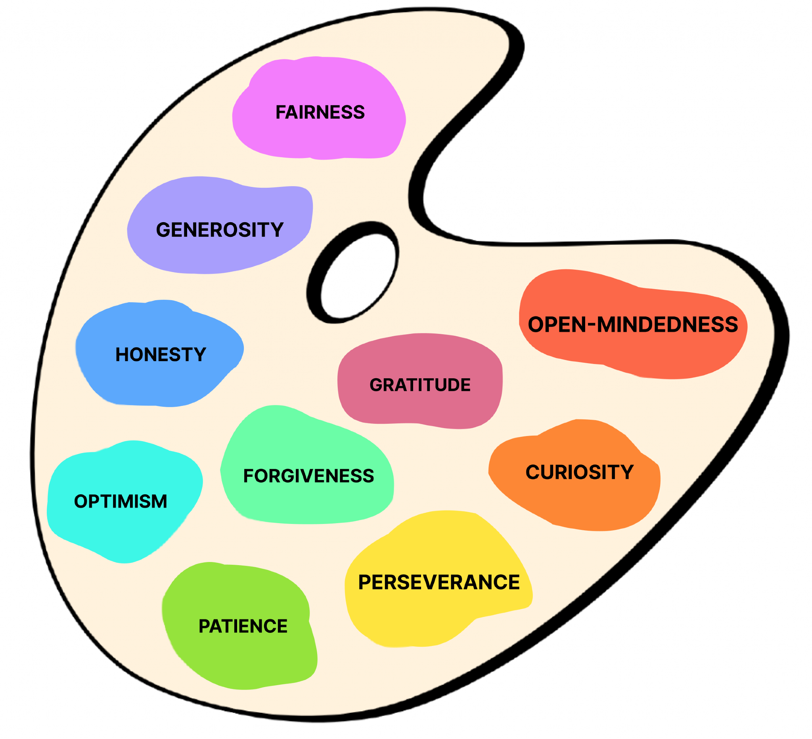

During the ScratchJr Blocks and Bots Curriculum, there are many opportunities for learners to collaborate.This document offers examples of how children can practice virtues from the Palette of Virtues while collaborating with others in three different ways: working together as a class, working within a pair, and working within a group. These examples are not exhaustive; children and educators can continue to add additional virtues and practices to their own palettes over time.

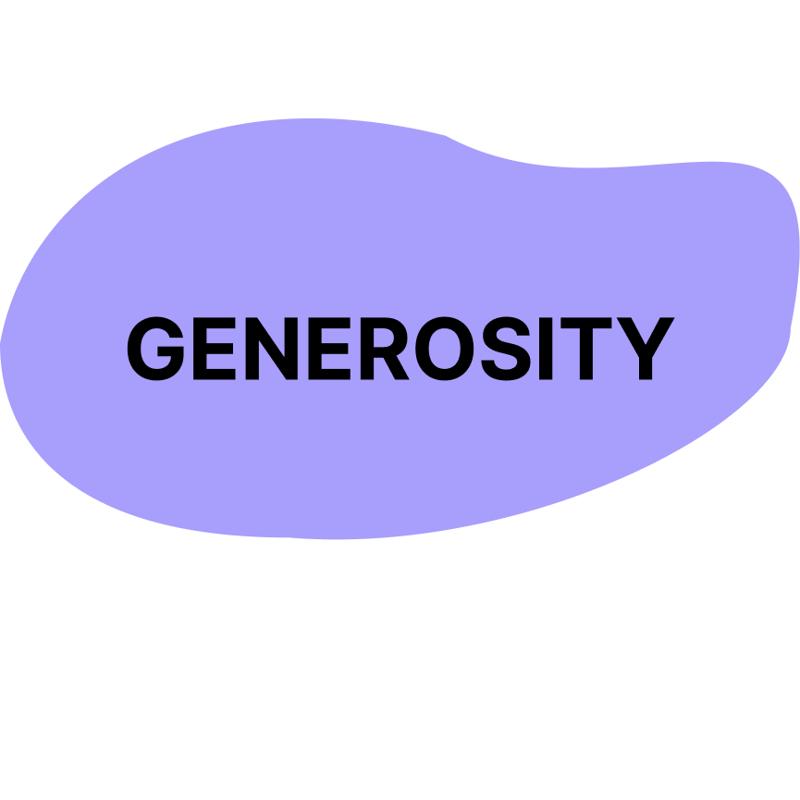
Being kind; giving and receiving; helping self and others.

When working as a whole group:
Across early lessons, children can practice generosity by sharing ideas about what they know, helping peers identify familiar blocks, and modeling how to care for shared tools. During activities such as storyboarding, rehearsals, and showcases, generosity can include offering encouragement, applauding others’ work, and helping the class stay organized.

When working in same-age or multiage pairs:
In paired work, generosity often looks like sharing control of materials, offering help when a partner is stuck, and patiently explaining ideas. Children can also practice generosity toward themselves by allowing time to explore and using kind self-talk during challenging moments.

When working in same-age or multiage groups:
In group projects, children can show generosity by dividing roles thoughtfully, sharing materials fairly, and supporting peers who need extra help. Generosity also includes stepping back to allow others to lead or contribute ideas.


Being honorable; acting with integrity; telling the truth

When working as a whole group:
During discussions in lessons, children can practice honesty by sharing what worked, what didn’t, and what they found confusing. Honest conversations about bugs, mistakes, or broken materials help build trust and a sense of shared responsibility.

When working in same-age or multiage pairs:
In pairs, honesty may involve clearly explaining one’s thinking, admitting when something was done accidentally (such as deleting a project or mis-scanning a block), and working together to fix mistakes without blame.

When working in same-age or multiage groups:
In group work, children practice honesty by respectfully sharing different viewpoints, acknowledging errors, and taking responsibility for their part in the project.

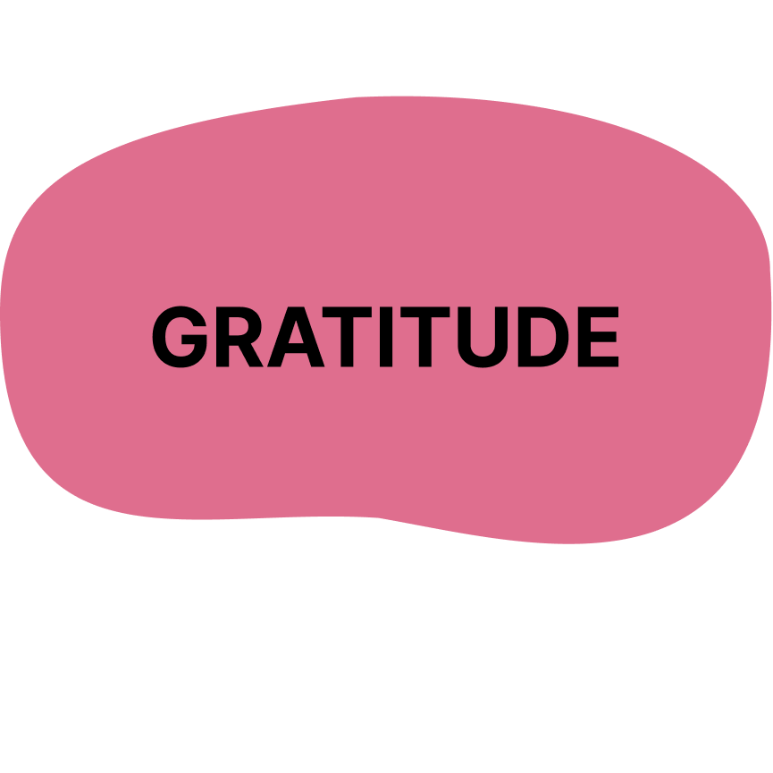
Being thankful; showing appreciation; noticing good things

When working as a whole group:
Children can practice gratitude by thanking classmates for ideas shared during lessons, and by appreciating group accomplishments after completing a program, story, dance, or filmed project.

When working in same-age or multiage pairs:
In pairs, gratitude may look like thanking a partner for sharing materials, helping debug a ScratchJr program, or being patient during Bot testing.

When working in same-age or multiage groups:
During group projects, children can express gratitude by acknowledging each member’s contributions and thanking peers during cleanup or reflection.

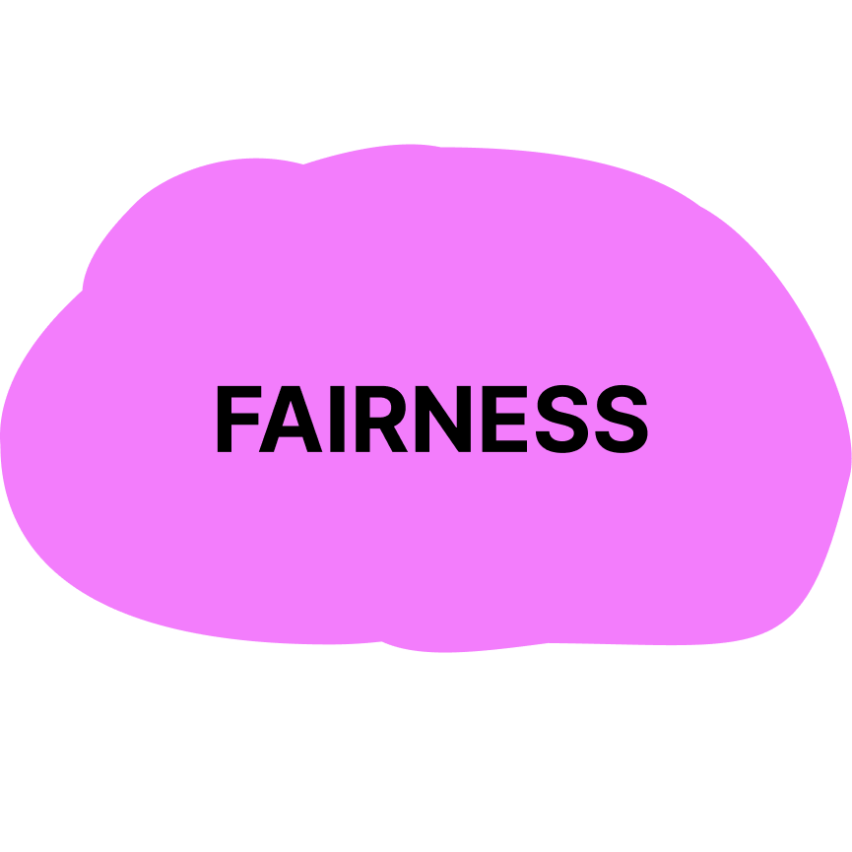
Treating others justly; sharing opportunities; avoiding favoritism

When working as a whole group:
Fairness can be practiced by taking turns speaking during discussions, following shared norms for using ScratchJr tablets or Bots, and respecting agreed-upon systems for sharing limited materials.

When working in same-age or multiage pairs:
In pairs, fairness may involve equal time controlling a tablet or Bot, making decisions together, and listening carefully to a partner’s ideas.

When working in same-age or multiage groups:
In groups, fairness includes assigning roles thoughtfully, sharing resources evenly, and ensuring all voices are heard during planning, programming, and rehearsal.

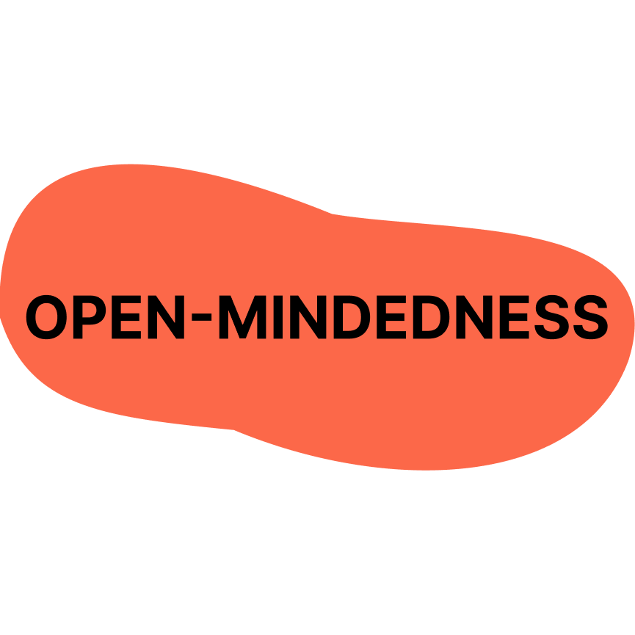
Willingness to consider new or different ideas, perspectives, and feelings

When working as a whole group:
During sequencing, repetition, and decision-making activities, children practice open-mindedness by seeing multiple solutions to the same problem and recognizing that different programming choices can all work.

When working in same-age or multiage pairs:
In pairs, open-mindedness may involve trying a partner’s idea, switching roles, or combining approaches such as using different blocks to achieve the same action.

When working in same-age or multiage groups:
In groups, children show open-mindedness by welcoming diverse ideas during collaborative planning, building, and rehearsal activities, and by remaining flexible when plans change.

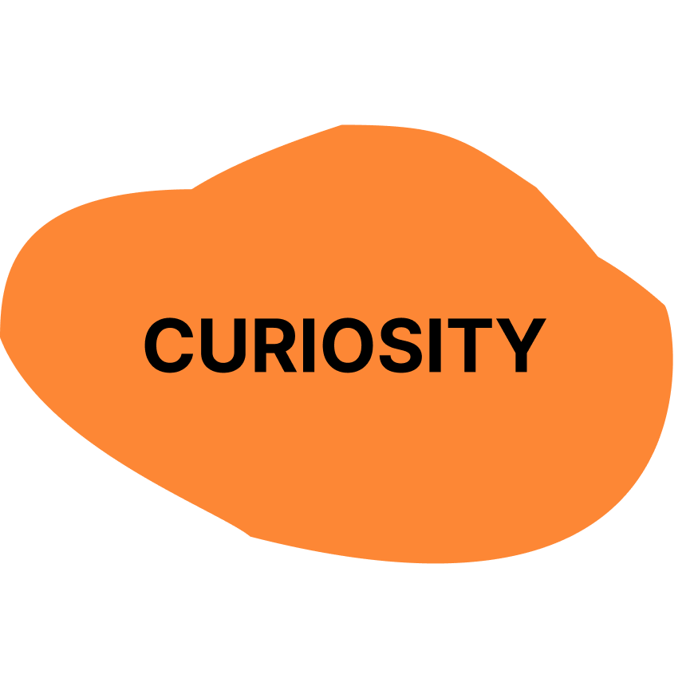
A strong desire to explore, ask questions, and learn

When working as a whole group:
Curiosity can be practiced by asking questions during tool exploration, block assignment, or physical computing activities, and wondering aloud about how tools and blocks work.

When working in same-age or multiage pairs:
In pairs, curiosity may look like experimenting with new blocks, testing different Bot actions, or exploring what sort of ideas your partner has.

When working in same-age or multiage groups:
In groups, children practice curiosity by exploring ideas together, seeking out new resources, and encouraging peers to try unfamiliar tools or creative approaches.

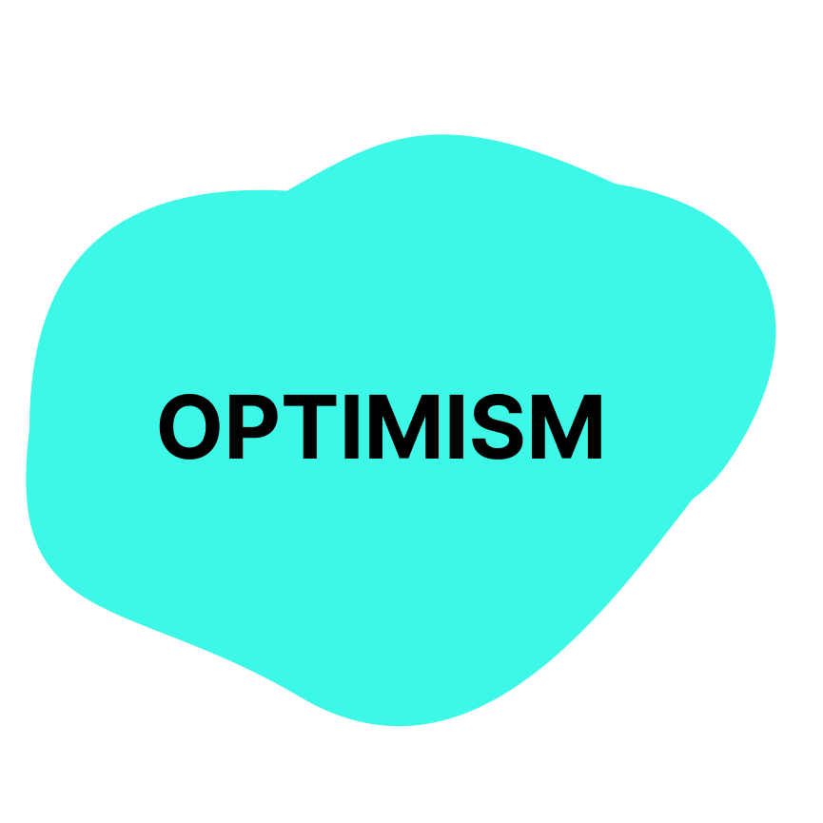
Hopefulness and confidence in growth and positive outcomes

When working as a whole group:
Children practice optimism when challenges arise during debugging, complex programming, or Bot malfunctions by keeping a positive attitude and believing that problems can be solved through effort, persistence, and collaboration.

When working in same-age or multiage pairs:
In pairs, optimism may look like encouraging a partner after a failed attempt and trying again with a new strategy.

When working in same-age or multiage groups:
In groups, children show optimism by supporting one another through longer projects, trusting the process, and celebrating progress as well as final outcomes.

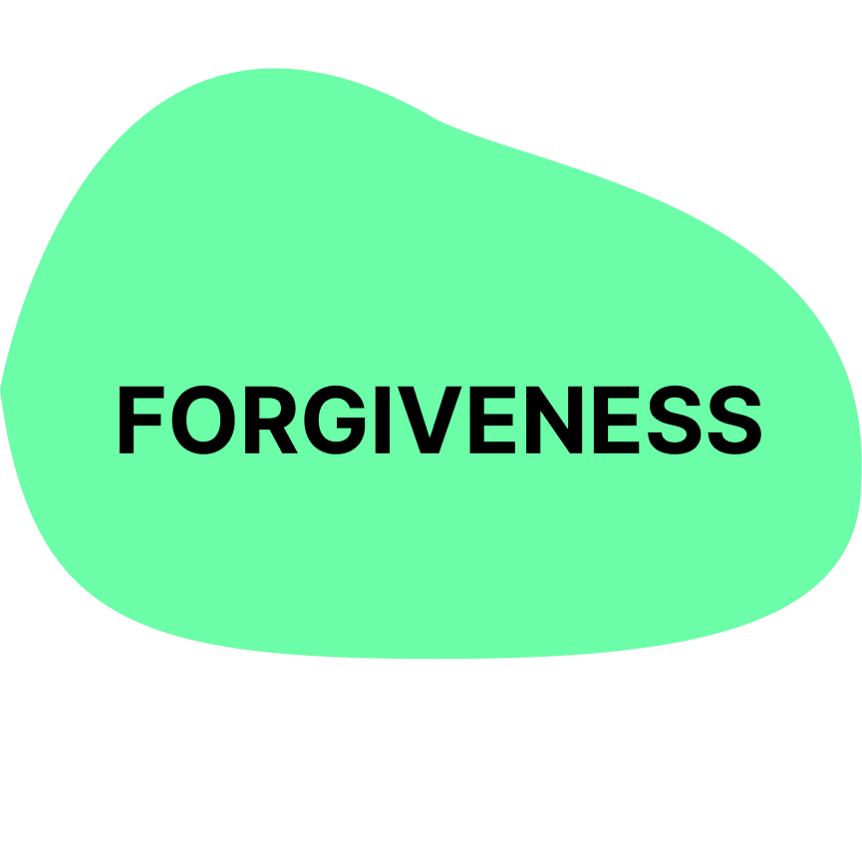
Letting go of mistakes and offering second chances to self and others

When working as a whole group:
Forgiveness can be practiced when mistakes happen such as lost pieces or broken programs by focusing on solutions rather than blame.

When working in same-age or multiage pairs:
In pairs, forgiveness may involve calmly responding when a project is disrupted, accepting apologies, and showing kindness after mistakes.

When working in same-age or multiage groups:
In groups, children practice forgiveness by resolving conflicts respectfully and allowing opportunities to try again during rehearsals or debugging.

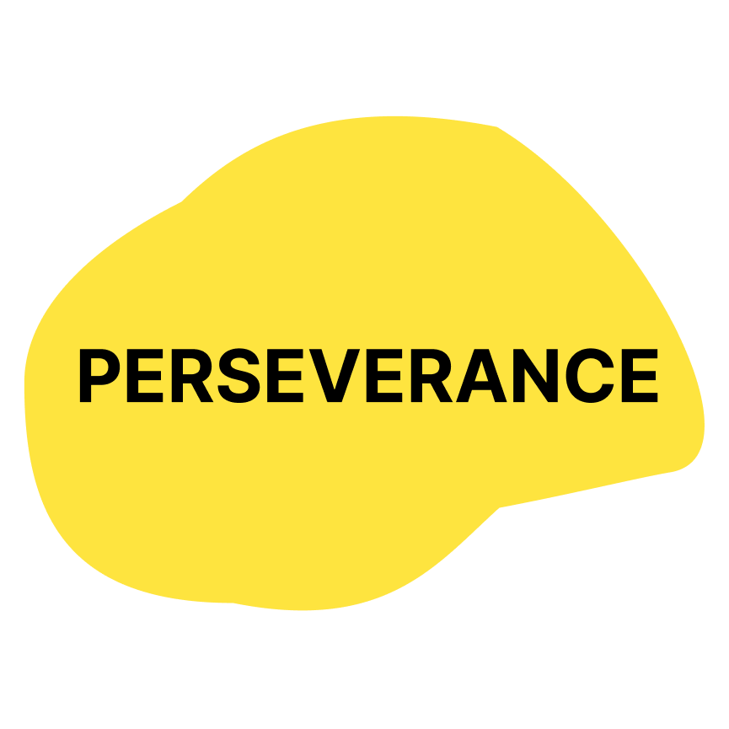
Continuing to work through challenges with determination

When working as a whole group:
Perseverance is modeled when the class works through difficult concepts like conditionals, circuitry, or debugging together, learning that struggle is part of the design process.

When working in same-age or multiage pairs:
In pairs, perseverance may look like testing multiple solutions, revising programs, and encouraging each other to keep trying.

When working in same-age or multiage groups:
In groups, children show perseverance by revising plans, debugging complex projects, and continuing to work toward shared goals despite setbacks.

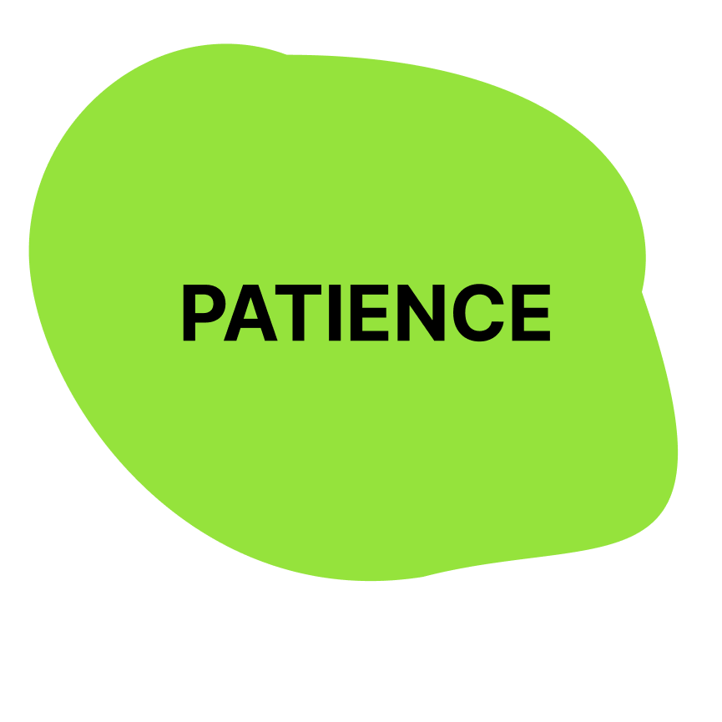
Remaining calm and respectful while waiting, learning, or facing difficulty

When working as a whole group:
Children practice patience by waiting their turn to speak, listening during demonstrations, and allowing time for others to think and respond.

When working in same-age or multiage pairs:
In pairs, patience may involve moving at a shared pace, waiting during Bot testing, or allowing time to understand a new block or concept.

When working in same-age or multiage groups:
In groups, patience supports collaboration during longer projects such as story creation, filming, and rehearsal, helping others work calmly through delays and challenges.

